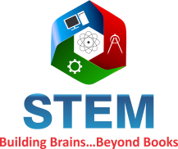
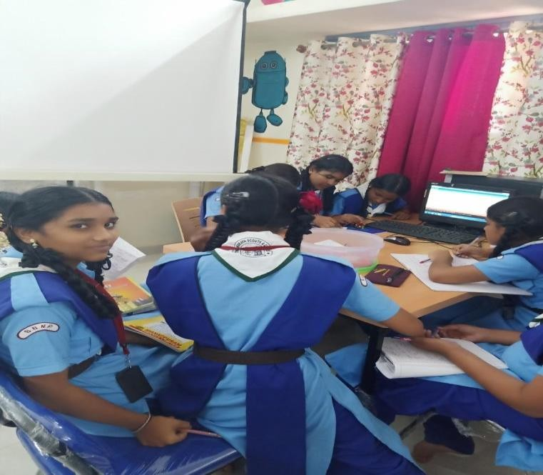

Proposal for STEM TINKERLAB
Under CSR Initiative of LG

Project Support requested under the Corporate Social Responsibility

1) | About STEM Learning | 3
2) | What is Tinkering | 4
3) | STEM Tinker Lab Project-What, Why? | 4
4) | Objectives, Outcomes, Content | 5
5) | Content Module description and pictures | 6-11
6) | Project Sustainability | 12
7) | Deliverables Per school | 12
8) | Steps of Implementation | 13
9) | Budget & Beneficiaries | 14
10 | STEM Tinker Training class wise yearly plan | 15
11 | TINKER Project Pictures | 16

ABOUT STEM LEARNING

STEM Learning believes that every child deserves access to quality education

Mission- To enhances students’ aptitude towards science & math so that they embrace it and grow with it while relishing the learning procedure.

Vision - To be globally recognized for introducing innovative learning products at the school level and contributing to society by making education easier for lesser-privileged students.

Goal - Making learning accessible to all children for aptitude enhancement. To ensure that the students have access to equal opportunities

What is Tinkering?

To put across simply, Tinkering is basically experimenting with various electronic, robotic and technology tools; understanding their potential and thereby creating a solution for any problem.

Tinkering involves:

- Identifying a problem and conceptualizing a solution.
- Thinking out of the box and above the conventional streams.
- Putting the idea down on paper and utilizing technology to give it shape and create a new entity, which may be local or/and global in nature.

What is STEM Tinker Lab?

- STEM TINKER LAB has been conceptualized to imbibe futuristic skill sets among students
- To empower and encourage the students to design authentic, integrated STEM project based learning that engages students in the work of real scientists, engineers and mathematicians, to engage students’ emotions, creativity and curiosity.
- To enhance their critical thinking skills and lateral thinking “outside the box”.

- STEM Tinker lab will contain educational and “do it yourself” kits and equipment on – science, electronics, robotics, open source microcontroller boards, sensors and 3D printers etc.
- EXISTING SCHOOL TEACHER will be empowered to use the resources and to conduct tinker session for students.
- Tinker Lab is a PERMANENT SETUP for underprivileged children in their respective schools.

Why do we need STEM Tinker Lab in school?

- How will we prepare our children for a world that is constantly changing?
- How will we prepare today's workers for jobs that don't even have titles yet?
- How will we prepare ourselves for a lifetime of learning?

We need a new set of skills, and a new way to learn.

- We are at a crucial stage when the Indian Government is promoting initiatives such as Make in India, Skill India, Digital India, Tinkering Labs to encourage manufacturing, technology usage and skill development in the country. STEM is turning out to be an essential and integral component of our education. Once a kid develops a passion for STEM fields, it smoothens the decision making process to choose a right field to pursue ones career. It will help to create great thinkers, innovators, engineers and scientists that our society and industry needs. This is essential for our future prosperity and to our nation in order to develop competitiveness and play a vital role in a global economy.

Objectives of STEM TINKER LAB

- Stimulate CURIOSITY, CREATIVITY and IMAGINATION in young minds.

- To inculcate skills such as DESIGN MIND SET, COMPUTATIONAL THINKING, ADAPTIVE LEARNING, PHYSICAL COMPUTING etc.

- To EMPOWER EXISTING TEACHER by continuous HANDHOLDING AND SUPPORT to use TINKER LAB at its best.

- To develop combination of “hands on” and “mind on “approach.
Project Outcome: SKILLSET IN CHILDREN

- Enhancement of Logical Thinking through algorithm, flowchart.
- Problem solving skill with limited resources.
- Application of Science, Mathematics, Technology and Engineering (STEM) Concepts.
- Improves Cognitive skills (knowledge), Affective (growth in self-attitude/feelings)and
Psychomotor skills (coordination, motor skill) in kids.

Project Outcome for TEACHER
- Teachers equip teaching methodology which enhances 21st century skills.
- STEM certification of teachers.
- Become a STEM peer leader for other teachers.

Project Outcome for SCHOOL:
- STEM Accreditation to the school.
- Permanent Tinker Lab in school.
- Capacity building and Empowerment program for existing teachers.

CONTENT OVERVIEW
These modules range from grade V to X students.

MODULE I - SCRATCH PROGRAMMING, HTML | This module is aimed to help understand the basics  Of algorithm writing, programming. With this students will create animation, stories, and games.  Students will build basic robotics racing car to perform  different activity.
MODULE II- BASIC OF ELECTRONICS, ARDUINO UNO, ROBOT STRUCTURE BUILDING | This module will focus more on physical computing, circuit making, algorithm and development of prototype using hardware and software.
MODULE III –  MOBILE APP DEVELOPMENT | In this module, the objective is to help in generating multiple mobile applications, which can be used in real life situations and understanding of IOT and its  importance.
MODULE IV-3D MODELLING & PRINTING, ROBOTICS | In this module we will focus more on designing 3D models using fusion 360 from Autodesk and get it  3D printed and students would get to use different kinds of  hardware and software - sensors, boards etc.
MODULE V –ADVANCE ROBOTICS, DRONE PROGRAMMING | In this module we will focus more on advance robotics activity where students will have to use programmable robots and perform the activity.

Description of Scratch Programming
  - Scratch is a visual programming language developed by MIT Media Lab.
  - Scratch was created to help young people learn to think creatively, reason systematically and work collaboratively.
  - It can be used for math and science projects, including simulations and visualizations of experiments, recording lectures, to social sciences animated stories, and interactive art.
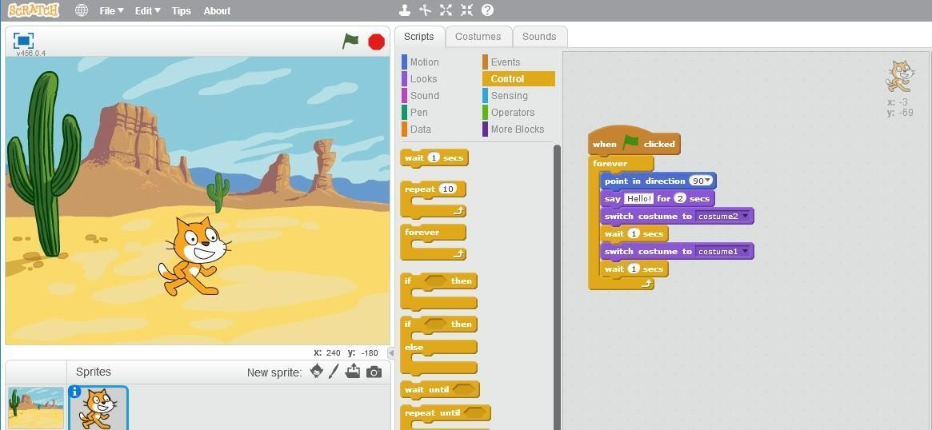
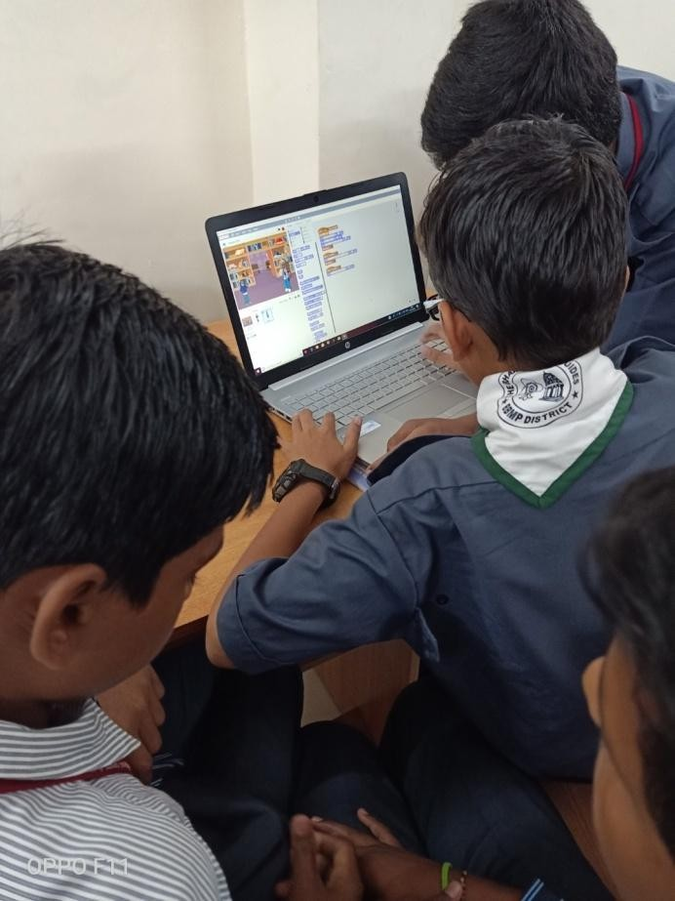

Description of Mobile App Inventor
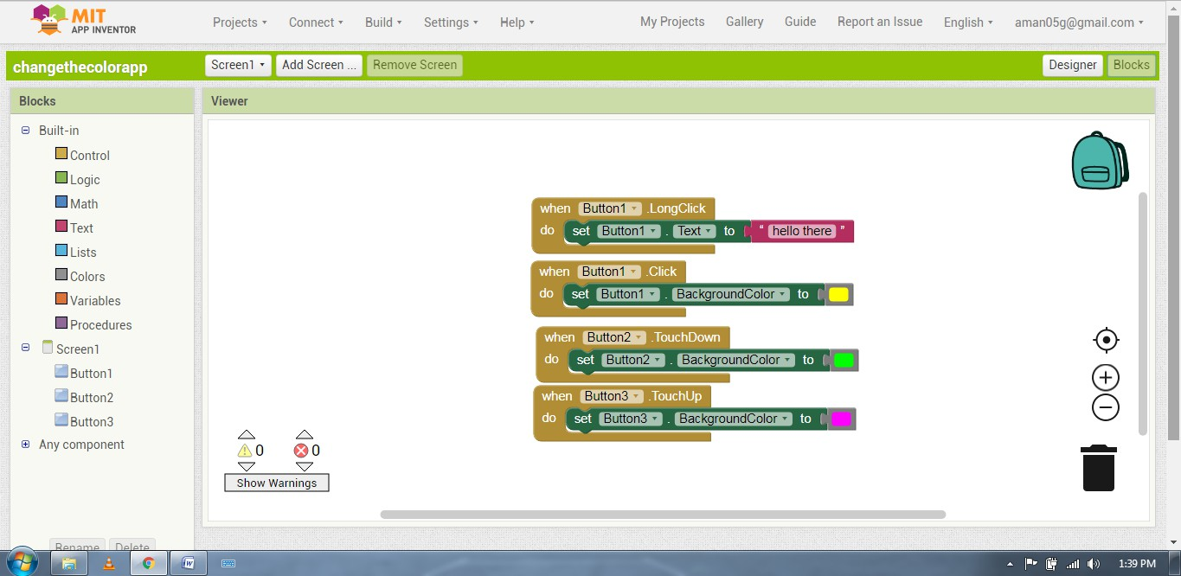
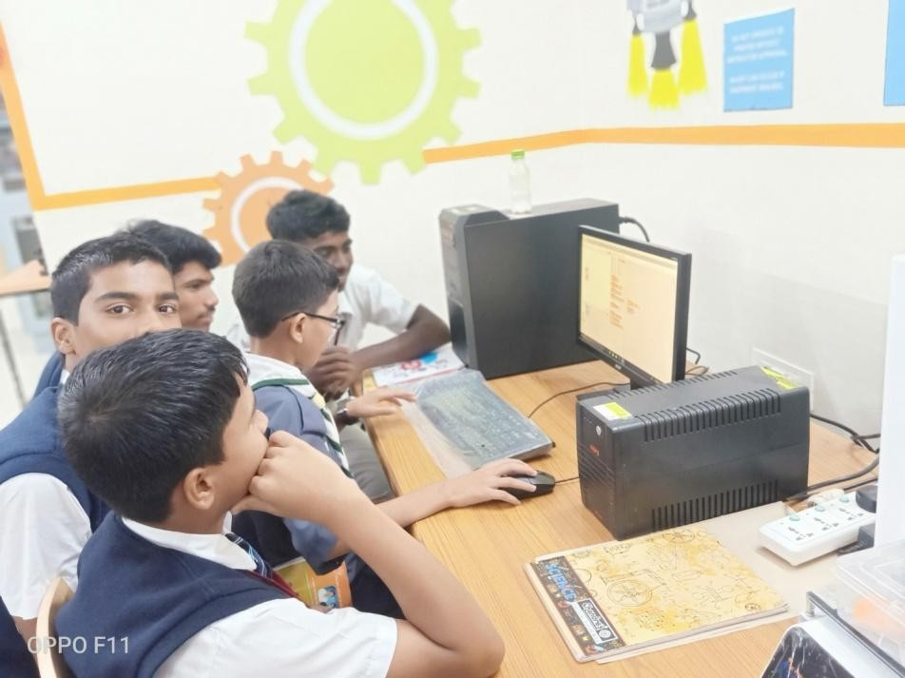
  - App Inventor is a visual, blocks language for building Android Apps. It is being used in classrooms all over the world to broaden participation in computer science. Students will be able to build games, social apps, quizzes etc.

Description of Arduino
  - Arduino is an open source electronic platform based on easy to use hardware and software.
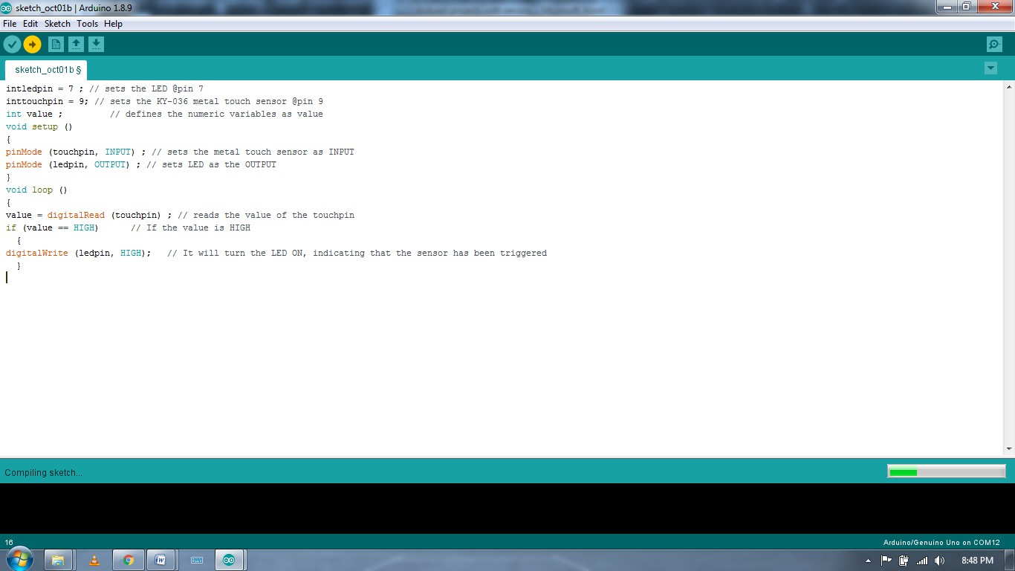
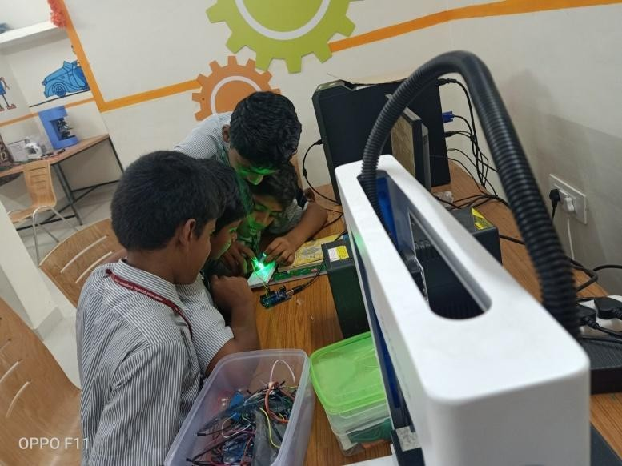
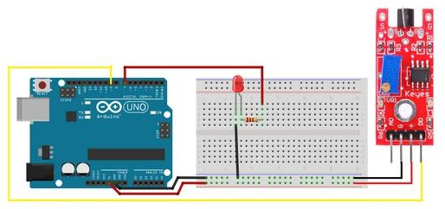
  - Arduino boards will allow students to build digital devices and interactive objects that can sense and control objects in physical world.

Description of Robotics
- Robotics is an interdisciplinary branch of engineering and science that includes mechanical engineering, electrical engineering, computer science, and others
- Students would get to use different kinds of hardware and software - sensors, boards etc. and construct an autonomous robotic car.
- Students will learn to write algorithm and program using Arduino software.

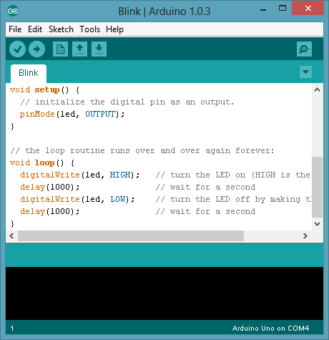
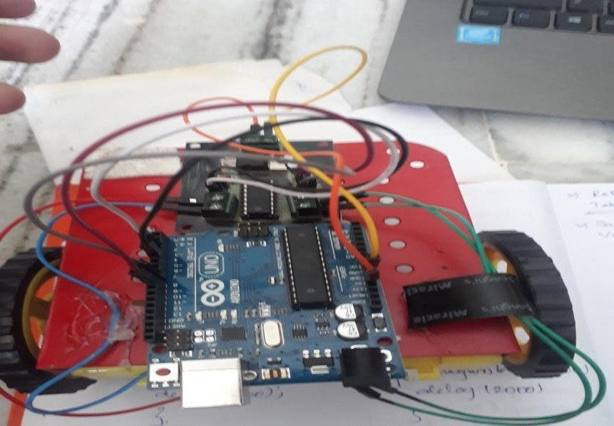

Description of 3D designing and printing
  - 3D printing is a technology that allows students to turn any digital file into a three dimensional physical object.
  - It allows rapid prototyping and customization. It will enhance hands on learning and learning by doing.
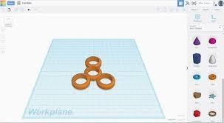
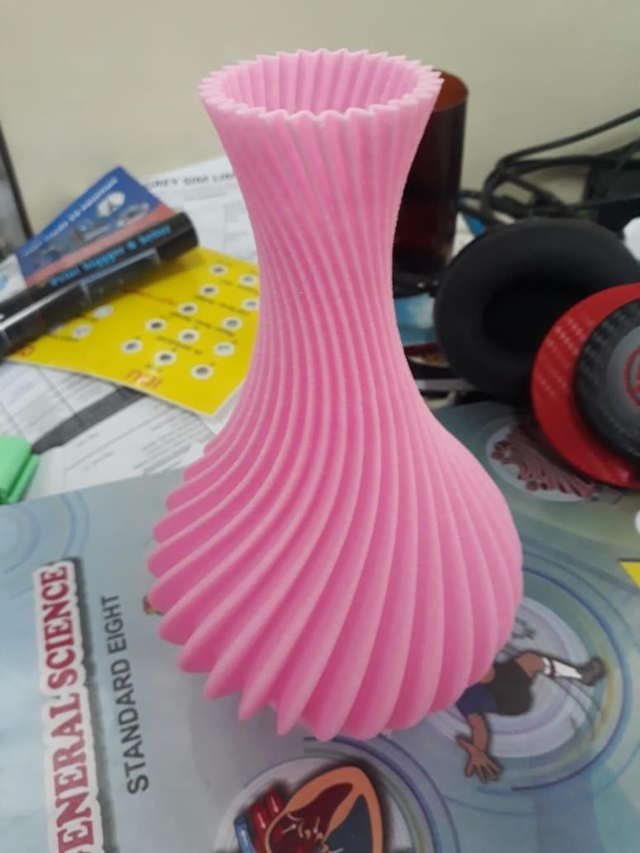
  - Students will be able to produce realistic 3D mini models and thus add on to the maker culture.

Project Sustainability
- STEM Tinker Lab is A PERMANENT INFRASTRUCTURE which is based in the school premises
- Tinker Lab OWNERSHIP with the school starts from the day of the orientation and setup; giving long term benefits to the schools and its students,
- EXISTING TEACHERS are trained and thus empowered to use TINKER lab for long term.
- For the corporate donor it ensures LONG-TERM BRANDING and VOLUNTEERING OPPORTUNITY too.

Deliverables (per school)

1) Deliverables for PERMANENT TINKER LAB ( 1 School)
Tools and Equipment | Learning Resource | Program
- Arduino kit(DIY)- 10 sets Micro-controller board  15 Types o sensors cables, Electronic items (LEDs, buttons) Breadboard  - Basic of Electronics kit – 10 sets( Breadboard, breadboard power supply, resistors, LEDs, buzzer, multimeter, etc)  - Robotics Kit (DIY)—10 sets Robot Chassis with wheel Micro-Controller Board Battery  Cables  Infrared Sensor, Bluetooth  - 1 DIY Robotics kit  - 1 Programmable Drone  - Mobile Phones—5  - 1 3D Printer  - Tools kit – 1  and Teachers Kit - 1 | - Lesson Plans (manuals)  - 4 months of Training programs. Trainer visits school in every week.  - Class room observation visits.  - Online training sessions ( if required )  - Certification of students and teacher. | - Tinker Fest ( Inter school competition and Project display exhibition)  - End line Document, Video and Photographs.
- Program Coordinator, Logistics and Administration

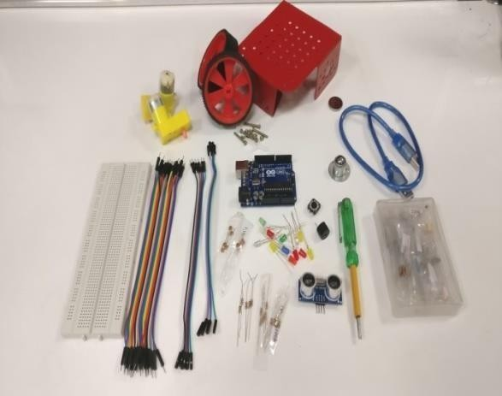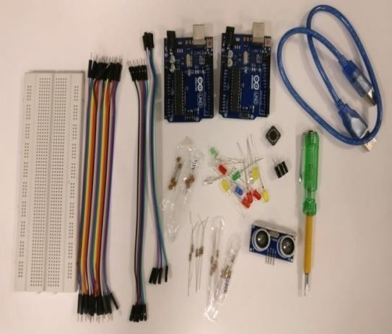

STEPS FOR IMPLEMENTATION

 | Tinker Program
1 | Identification of school
2 | Orientation of Teachers & Principal- Introduction to Tinker Lab, activities, instruments and benefits of the same to teacher and students.
3 | Train the teacher- Continuous handholding and training of teacher for each activity.
4 | Tinker Session for students – Selected and interested students will attend their respective sessions.
5 | Competition and Felicitation Program – students will showcase their projects, innovations and ideas. Teacher and student will be provided with certificate.
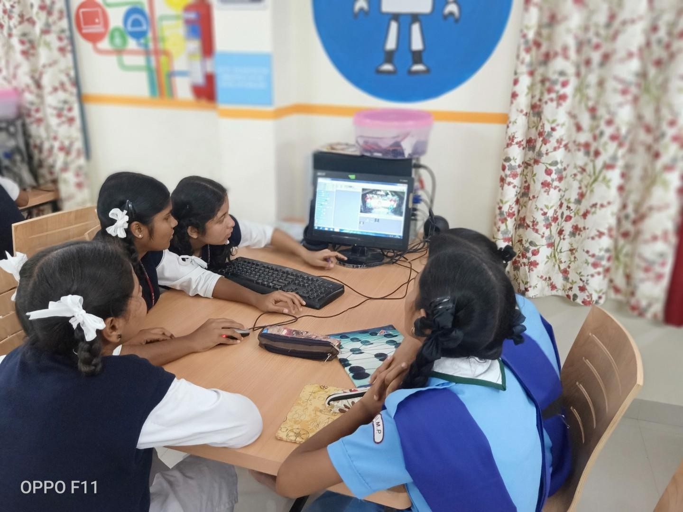

Budget
PROJECT BUDGET
`SR. NO. | BUDGET CATEGORIES | Tinker lab cost per school
1 | STEM Tinker lab Set up cost  - 5 Android Mobile  - 10 Arduino Program kit (Include Arduino UNO and General Purpose Sensors like IR sensors, LDR sensors, Ultrasonic Sensors, etc.)  - 10 Basic Robotics Kit (Includes wheels, chassis, Motor Driver, Arduino Uno etc.)  - 10 Set Of Basic Electronic Components (Include Resistors, Capacitors, LEDs, etc.)  - 1 App Controlled Drone  - 1 Advance DIY Robotics kit  - 1 Teacher Kit  - 1 Tool Kit  - Backdrops & installations  - Chairs & Tables | 2,50,000
2 | Learning Tools  ( Training Manuals and Software Installation ) | 50,000
3 | 1 - 3D Printer  ( including Consumable) | 1,35,000
4 | Training  ( 15 Training in each schools with reporting and documentation) | 1,50,000
5 | Laptop | 40,000
Sub-Total |  | 6,25,000
GST @18% |  | 1,12,500
Grand Total |  | 7,37,500
Note:
Project cost Tinker lab for 1 School for 1 Year including GST is RS. 7,37,500

STEM Tinker Training class wise sessions:

S.NO. | Module | Time Period
1 | Scratch Programming | 1 Week
2 | Mobile App Inventor | 1 Week
3 | HTML | 1 Week
4 | Basics of Electronics | 1 Week
5 | Arduino | 3 Week
6 | Robotics | 2 Week
7 | Advanced Robotics ( Drone and  Humanoid Robot ) | 3 Week
8 | 3D Printing and Modeling | 2 Week
9 | Career Guidance | 1-2 Sessions

Note: Considering School’s examination time table and vacations, this above mentioned schedule is the yearlong schedule.
Tinker samples videos link: https://www.youtube.com/watch?v=xS4mcOX0H4Y https://www.youtube.com/watch?v=LRK7XnR3sJU

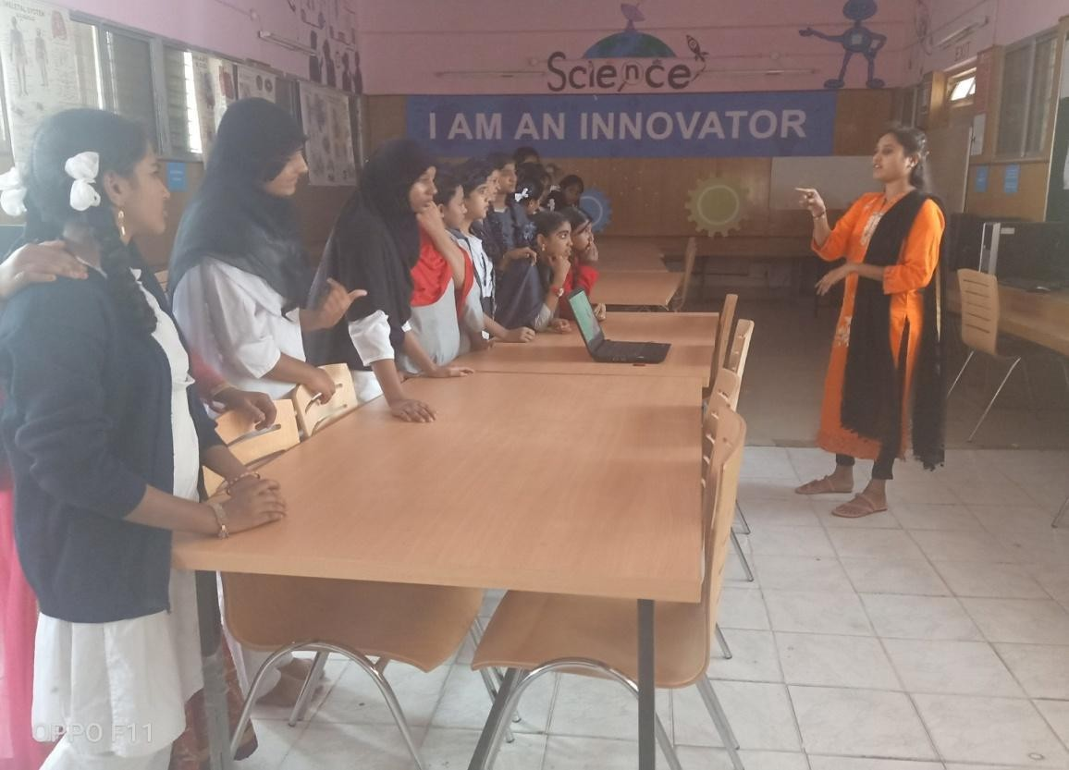
Tinker Training Session in Padaranpura Girls School

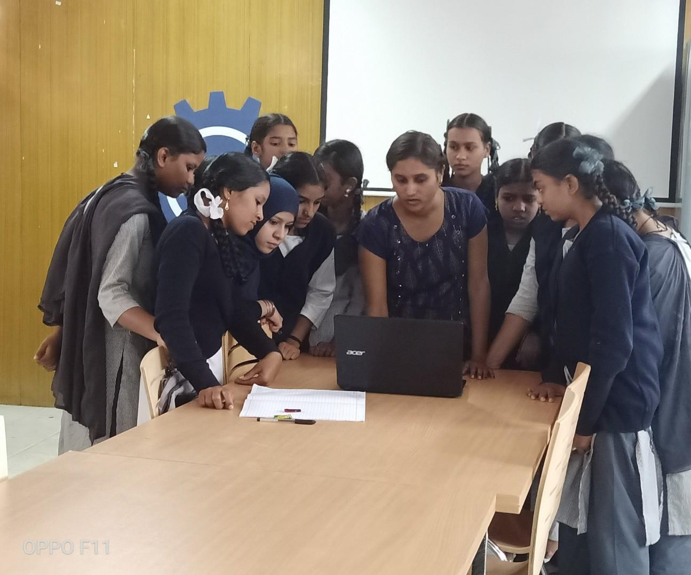
BBMP Ganganagar Schoolstudents and Stem trainer exploring Tinker Session.

THANK YOU

