Seva Sahayog Foundation
Corporate Social Responsibility

Proposal for Mini Science centre’s

Tamil Nadu Dover INDIA Limited.

July 2023

Introduction to Seva Sahayog Foundation (SSF): 2
Project Background / Current Scenario: 5
Beneficiary outreach: Stakeholder wise projects 6
Current activities of Seva Sahayog 6
Proposal: Mini Scince centre Proposal for six schools in Washim district 8
Budget 8
School List: 9
Our execution methodology: 11
Sustainability plan of our programs: 13
Monitoring and Evaluation: 13
Reporting method & schedule: 13
The board of directors of Seva Sahayog Foundation: 14
Annexure I 16
Science & Technology Education Program (S.T.E.P.): 16

Introduction to Seva Sahayog Foundation (SSF):
Seva Sahayog Foundation is a registered (August 2009) NGO working with a vision to bridge the gap between the “struggling” mankind and the “aspiring” mankind. The organization aims at engaging socially active corporates, groups, and individuals on one hand and needy grassroots communities on the other, matching their mutual interests.
The organization has been networking with like-minded individuals from various corporate to create an impact at the grassroots level.

6 Lakhs Beneficiaries in FY 2020-21 | 19 Thematic projects | 150 Corporates | 25,000 volunteers

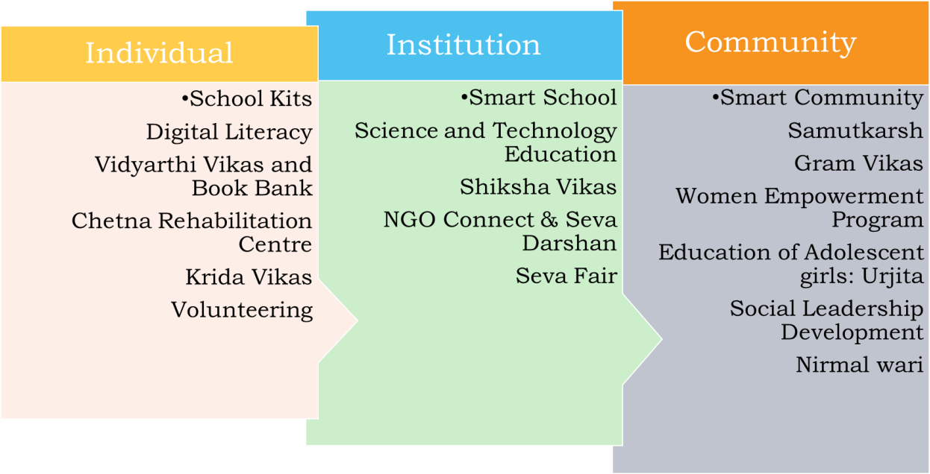
The projects are geographically spread across 27 districts of Maharashtra with a strong engagement in 700 schools, and 190 communities. With a full-time staff of 60 individuals, the projects of the organization are categorized in a manner to make an impact at the grassroots through the following segments.

The project footprints to date are as follows:

School Kit Drive   | School Infrastructure development   | Samutkarsh: Study Centres   | Gram Vikas: Village Development   | Sports  
4.5 Lakhs till date | 190 Schools | 190 Centers | 5 villages | 2 Academies

The mission is to build a network of socially conscious people within India and around the world which will be a pool of resources with financial strength, knowledge, commitment, and vision to transform India.

Vision 2030 of Seva Sahayog

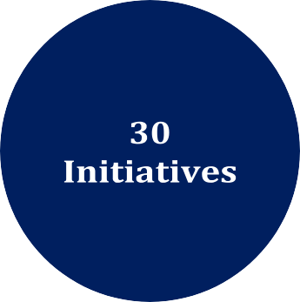

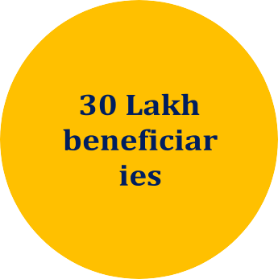

Seva Sahayog Foundation has been able to make footprints on the 16/17 sustainable development goals of the UN and Niti Aayog through various interventions.

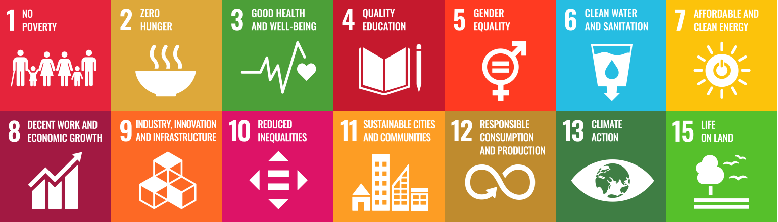
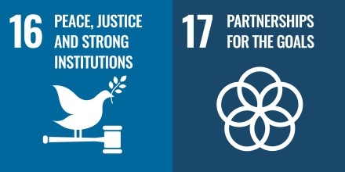

Project Background / Current Scenario:
According to the 2011 census, 69 percent of India’s population lives in rural areas, amounting to roughly 833 million people. The reality of rural India is far from the idyllic scenes of bucolic farmlands. It is characterized by poverty, unemployment, underemployment, and a lack of access to basic services such as quality education and healthcare. From an environmental perspective as well, the region is grappling with the degradation of natural resources, reducing soil fertility, and the depletion of groundwater resources. These factors contribute towards a vicious cycle of poverty and deprivation, stressing rural livelihoods, depressing incomes, and compromising quality of life. Rural indicators for human development consistently lag behind national averages and urban counterparts.

Science is knowledge about the material and natural world. It is knowledge produced from systematic observation, measurement, experimentation, exploration, and speculation and the origin about natural objects, their properties, and their interactions. Science curriculum directs attention to the material world, to things and processes in it; about which it would likechildren to learn—to notice, name, and think about things based on concepts and theories. However, a disciplinary approach is essential in learning but it is also imperative to ensure that we make the subject interesting. This not only limits the learning of students about the subjects of Science & Math’s but also reduces the interest of students in these subjects and a fear psychosis is created in their minds for these subjects.
Expected outcomes are aptitude of students for learning science and mathematics improved by creating a simple, child-friendly ecosystem which is fun and enjoyable. Empowering teachers with easy teaching aids. Improve teaching pedagogy by use of models in conducting the science and math’s classes through better engagement of teachers in teaching. Increased self-confidence in tackling problems in science & Math’s classes and projects. Increased learning levels are observed.
A baseline survey will be conducted to analyze the students and also after the project completion and endline survey will be conducted.

Beneficiary outreach: Stakeholder wise projects

Stakeholder | Projects
Students and Youth (Age Group 7 to 25) | School Kit Drive
Students and Youth (Age Group 7 to 25) | Smart School
Students and Youth (Age Group 7 to 25) | Digital Literacy
Students and Youth (Age Group 7 to 25) | Krida Vikas
Students and Youth (Age Group 7 to 25) | Science Technology Education
Students and Youth (Age Group 7 to 25) | Shiksha Vikas - School Infrastructure Support
Students and Youth (Age Group 7 to 25) | Samutkarsh - Study Centres
Students and Youth (Age Group 7 to 25) | Book Bank - Text Book lending program
Students and Youth (Age Group 7 to 25) | Vidyarthi Vikas - Financial assistance to meritorious students
Students and Youth (Age Group 7 to 25) | Skill Development training and Education
Students and Youth (Age Group 7 to 25) | Social Leadership Development Program
Women | Women Empowerment program
Women | Skill Development / Micro Entrepreneur Program
Women | Development of adolescent girls (Kishori Vikas)
Community members | Smart Community
Community members | Gram Vikas
Community members | Nirmal Wari

Current activities of Seva Sahayog

Some of the major programs initiated by SSF are under CSR Activities:
- School Kit Drive: This program has outreached to more than 400,000+ deserving students wherein all stationery items with a school bag is provided to each student based on which standard the student is.
- S.T.E.P (Science Technology Education Program): This program is designed to develop an interest in science & technology within the school going students. The program is aimed to benefit schools catering to underprivileged students in urban and rural regions near Mumbai. SSF has developed more than 100+ schools through the program. (Photo in Annexure -I attached below)

- Science Laboratory: The program allows the students to perform science experiments in the schools lacking proper laboratory setup. Trained resources at the facilities demonstrate and explain the experiments, thus making the learning process simple. The project currently caters to 160+ Schools in Mumbai, Raigad, and Pune.
- Gramvikas (Village development): SSF is currently working in more than 20 hamlets in Karjat and a couple of them in Palghar and Pune district for the overall development of the hamlet through education, vocational training, women empowerment and community development.
- Shiksha – Vikas: A school centric program run in 40+ schools, focusing on the development of school & community through intervention and participation of Students, corporate employees, parents & school teachers. We have a keen focus on smart school initiatives.
- Book Bank: A textbook lending facility for 1500+ under-graduate to post-graduate underprivileged students on a returnable basis.
- Krida Vikas: Well-equipped sports facility serving as a hub & spoke model with student participation from 15 schools in Karjat. The program aims at training the students, maximizing exposure, facilitating participation in sports events, and support students with latent skills in sports.
- Samutkarsh: A community-centric program running in 170 settlements, focusing on te development of school children & community through regular after school hours coaching centers.
- Environment: Tree plantation with the help of corporate volunteers and development of urban dense forest using Japanese technology.

Proposal: Mini Scince centre Proposal for 2 schools in Tamil Nadu.

Budget
BUDGET:
SR.NO | ITEM | DESCRIPTION | 1  SCHOOL | NOS OF SCHOOLS | TOTAL
1 | MINI SCIENCE CENTRE | 80 MODELS + 80 USERS PLACARD+ 40 COLOURFUL BACKGROUNDS + 1 SAFETY PLACARD + 1 TEACHERS MANUAL INCLUDES INSTALLATION, DELIVERY & 1st YEARS MAINTENANCE | 3,91,700 | 2 | 7,83,400
2 | TRAINING OF TEACHERS (TTP) | CLUSTER TRAINING (1-5 SCHOOLS) WITHIN 25 KMS RADIUS 1st YEAR -2 | 47,200 | 2 | 94,400
3 | MONITORING & EVALUATION | Total - 2 visitsin idividual schools | 47,200 | 2 | 94,400
4 | ANNUAL MAINTENANCE CONTRACT | CLEANING SERVICING & IF  REPLACEMENT (if any) ( appalicable from second year) | 47,200 | 2 | 0
5 | INFRASTRUCTURE | SET UP OF PLATFORMS & ELECTRIC CONNECTIONS | 47,200 | 2 | 94,400
TOTAL (1+2+3+4+5) |  |  |  |  | 10,66,600
6 | Admin Cost | SSF Admin Cost | 5% |  | 53330
 |  |  |  |  | 11,19,930

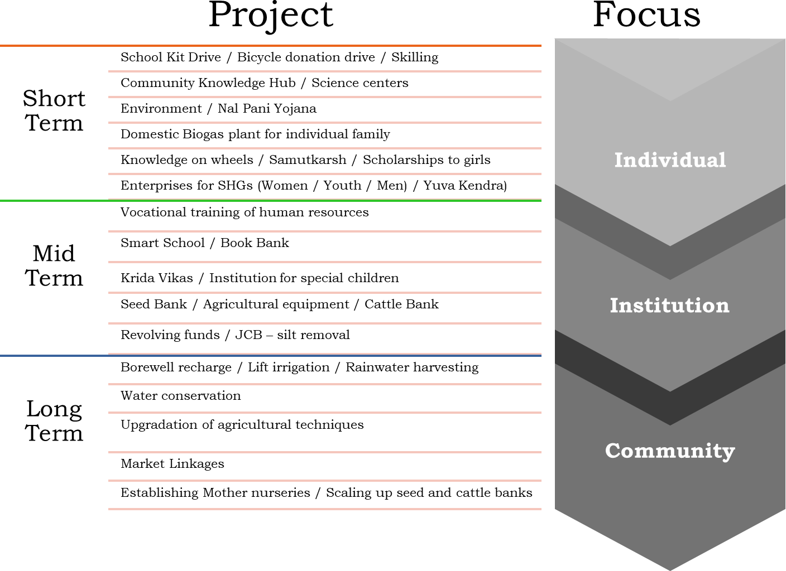

Our execution methodology:
The pandemic and the restrictions have resulted in the organization adopting a hybrid methodology to enable the team to achieve the deliverables and create an impact. The current strategy adopted by the team is a combination of waterfall and scrum methodology.

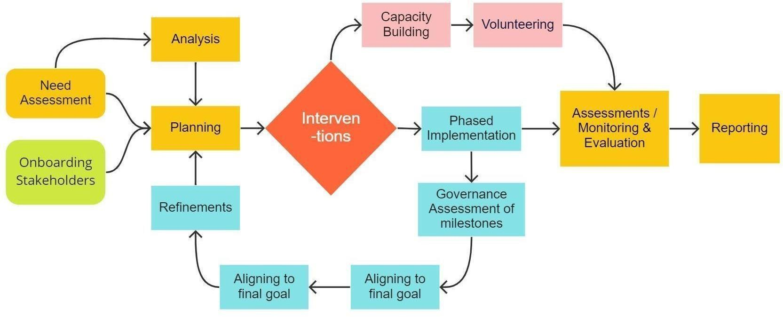

Sustainability plan of our programs:
The intervention is ensured through behavioral change i.e. Change Management Ensuring ownership of the program by the beneficiaries
The exit plan of the program ensures handholding the stakeholders in successful operations of the program within the defined period
Active volunteering

Connecting appropriate resource persons.

Monitoring and Evaluation:

The monitoring and evaluation of the program shall be conducted by SSF. Following elements shall be considered for the monitoring and evaluation:

- Pre & Post assessments
- Visible & Non-visible change pattern
- Feedbacks
- Reports
- Documents

Reporting method & schedule:

The reporting of the program shall be as mutually agreed.

Seva Sahayog Foundation follows the following pattern of reporting:

Quarterly: Activity-wise, Resource, and fund-utilization reports
Annual: Impact assessment report and Complete Program Report

------****----

The board of directors of Seva Sahayog Foundation:

 | Mr. Atul Nagras – Chairman of Seva Sahayog Foundation, An engineering graduate, worked in the USA for a Semiconductor Devices Manufacturing company. Presently, Director of an IT company and an equipment manufacturing company
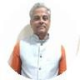 | Mr. Dilip Moghe – Chemical Technologist from UDCT, Mumbai. Worked in the corporate sector for 25 years. Currently associated with many other NGOs.
 | Mrs. Maneesha Joshi– A commerce graduate working as an independent accounting consultant
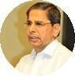 | Mr. Ravindra Karve – Banker, Retired CEO of TJSB Sahakari (Multi State Scheduled) Bank

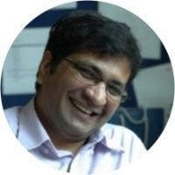 | Mr. Sudhir Patel - CA, CPA, CISA - finance professional with 20+ years of diverse global experience in the field of finance, management, and technology, having worked with startups and transglobal companies like PriceWaterhouseCoopers, Ernst & Young, ConocoPhillips in several leadership roles.
 | Mrs. Pallavi Kadadi – IT professional & entrepreneur, currently working with Krishna Infotech.
 | Mr. Makarand Soundalgekar - Civil Engineer by education having 20+ Years of experience with TATA Group in Project Management of large-size infrastructure Projects. Currently a professional trainer in Project Management, Business Excellence, and Group behavioural training.

Annexure I

Science & Technology Education Program (S.T.E.P.):
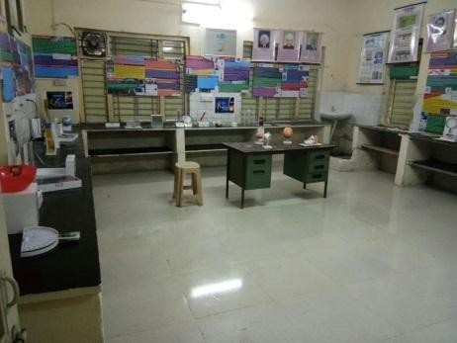
STEP is to promote Science & Technology among rural and urban poor students. Under this project a Mini Science Centre, Projector and E learning software, Digital Microscope with Laptop, 3 D models & Charts and Library are provided to schools. Teachers are given training to handle these equipment’s.Students find it simple to understand scientific principals with these educational
aids. The project is in its 3rd year of implementation. In the current year 25 schools will be covered. In first two years 31 schools were benefitted. Number of beneficiary students is 20,000.

