Shared design | Required changes
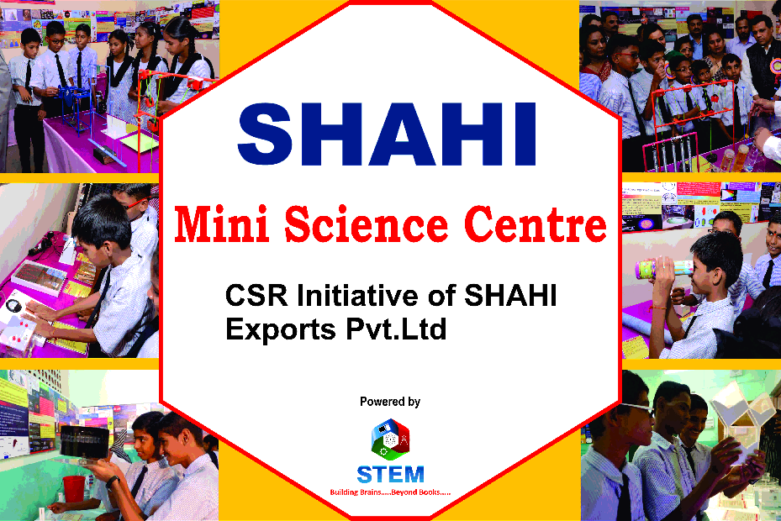 | SHAHI (Logo)  MINI SCIENCE CENTRE  Powered by  STEM (Logo)
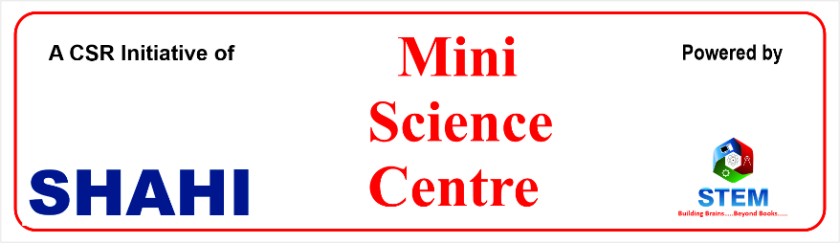 | Powered by SHAHI (Logo)  MINI SCIENCE CENTRE  STEM (Logo) CSR Initiatives of  SHAHI Exports Pvt Ltd.,
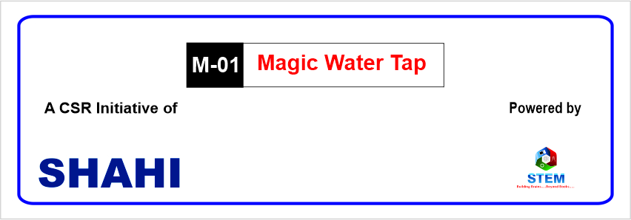 | Powered by SHAHI (Logo)  M-01 Magic Water Tap  STEM (Logo) CSR Initiatives of  SHAHI Exports Pvt Ltd.,

