To, Date: 25th October 2024
Ms. Chandrashekhar Deshmukh,
Chief HR Officer and Legal Head
Kokuyo Camlin Pvt Ltd
Respected Sir,
Greetings from STEM Learning! A social enterprise, which is conceptualized with an aim to empower children from rural and semi urban communities with the basic concepts of STEM Education. We have 13 years of experience of inculcating scientific temper among school children, now we have a presence in 27 states and have served more than 2500+ schools, in that over than 1 million underprivileged students get benefited, apart from that we have trained more than 7000+ teachers, and also, we are partnered with 175+ (PSU's, Corporate’s, NGO's & NPO's across PAN India).

Mini Science Centre (MSC) is a prerequisite for teaching science and math's to school children in a simpler way. Our Program involves setting up of Mini Science Centre (MSC) in schools to help children from standard 5th to 10th. The models are hands-on & facilitate effective teaching. We provide 80 hands-on, table-top, plug n play & fun-loving interactive models in accordance with the syllabus of STATE Board.
STEM concept is growing worldwide as it aims to lessen the gap between contextual and rote based learning. The objective is replacing it with a physical and practical approach, which will equip children with the skills and knowledge needed to get lucrative opportunities in their field of interest. It aims to ignite curiosity, inquisitiveness and passion for learning among the children so that they can opt for their higher studies and beyond.
In continuation with this letter is a detailed proposal for your consideration and perusal. We look forward to hearing from you with your support.
Thanking you,
Sadanand Shetty
Sr. Marketing Manager
STEM Learning Private Limited



Strategic Proposal for Mini Science Centre
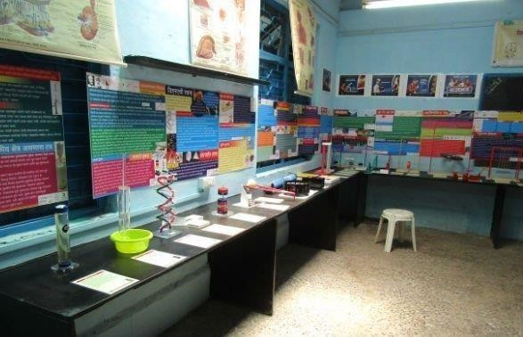

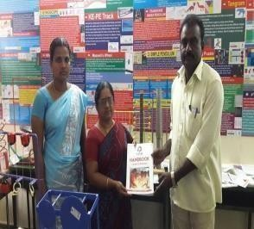
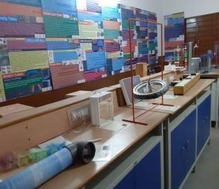
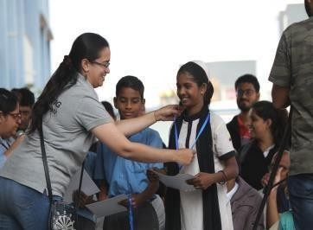
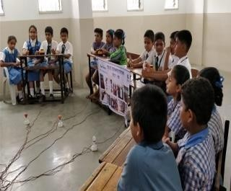
Mini Science Centre Teacher Training Program Science Competition Monitoring & Evaluation

Contact Persons:

Name: Mr. Ashutosh Pandit Name: Sadanand Shetty

Designation: Founder & MD Designation: Sr. Marketing Manager
Organization STEM Learning Pvt.Ltd. Organization: STEM Learning Pvt.Ltd.
Email: ashutosh@stemlearning.in Email: sadanand.shetty@stemlearning.in

Telefax: - 022 24933738 Mobile: 9987352626, 8356836210
Website: www.stemlearning.in

Contents
- ABOUT US.
- MISSION, VISION, GOAL, OBJECTIVES.
- STRATEGIC AREA OF FOCUS, PROJECT NEED.
- PROJECT SUMMARY STATEMENT, EXPECTED OUTCOME.
- STEM PROJECT LOCATIONS, LIST OF ACTIVITIES.
- PROJECT IMPLEMENTATION STRATEGY
- METHODOLOGY
- OUTCOMES, IMPACT ASSESMENT
- FINANCIAL IMPLICATIONS
- SUSTAINABILITY PLAN, CONCLUSION
- WORK PLAN NARRATIVE, TENTATIVE TIMELINE PLAN, WORK FLOW & PROJECT LOCATION AND SCHOOL DETAILS
- LIST OF 80 MODELS

1: About: STEM Learning Pvt Ltd -

STEM Learning was conceptualized with an aim to inculcate basic concepts of Science, Technology, Engineering, Mathematics at school level, thereby encouraging inclination of students / learners towards science and technology. Models designed by STEM help students in identifying and experiencing the actual concepts which they learn from text books making it more practical in approach
STEM believes that school education can’t be only visual or audio but it is important for the children to practically feel the products and experience it. With this vision, STEM has customized 80 models based on 130+ concepts of Science and Math’s for better learning and understanding of the concepts. STEM believes in adding more models for improved learning of students especially for those from less privileged section of the society.
STEM through its MSC’s have benefitted over 1 Million students with 7000+ teachers in 2500 + schools across 27 states in India. In addition to this, STEM learning also has a niche in installing 30 big science Centre’s in different talukas of Maharashtra under Manav Vikas Mission Project of Maharashtra Government. These Science Centres have trained more than one lakh students who otherwise would have never got chance to experience and explore science in a practical and easy way.
STEM’s models are approved by 6 SCERT- Maharashtra, Goa, Chhattisgarh, Odisha, Nagaland and Jammu & Kashmir for their alignment with the curriculum and the approvals by the SCERT’s of Andhra Pradesh, Telangana and Karnataka are awaited for approval.

2A: Mission Statement -
To enhance students’ aptitude towards science & math so that they embrace it and grow with it while relishing the learning process.

2B: Vision Statement –

To be recognized globally for bringing innovative learning products in School Education and contributing to the society by reaching to the less privileged students
2C: Goal -
Learning made accessible to all children for aptitude enhancement.
2 C.1: Immediate Goal: Reaching to Large population of under privileged Children Pan India
2. C.2: Aim: Ensuring equal opportunities for learning and development of all under privileged Children.
2. C.3: Immediate Aim: Reaching 2000 schools in the academic year 2021-22.
2. C.4: Objective: Empowerment/Enhancement of aptitude of children.

2D: Specific Objectives -
To ignite scientific interest in children so that:
- Question intelligently.
- Learn through discovery.
- Connect scientific knowledge to their world
- All of these are expected to strengthen scientific temper in children, thus laying the foundation for a flourishing career in Science & Mathematics.

3A: Strategic areas of Focus -
  - Providing quality teaching aids to improve teaching methods for students from lesser privileged sections of society.
  - Enhancing a positive attitude, learning capacity, and skills of students.
  - Providing a platform where students and teachers can volunteer for customized engagement programs/events.
  - Creating partnerships and collaborating with various stakeholders to ensure sustainability of the project.

3B: Background and Project Need -
The education system in India is undergoing a transformational process with special emphasis on Science and Math’s education. Science education in India is faced by various practical challenges today. The first and the most basic problem that has persisted and resisted solution since early education, is our inability to ease the fear of difficult subjects such as science and math’s and make it simple and fun so as to help retain the knowledge and strengthen the foundation of the child for future.
Science is knowledge about the material, natural world. It is knowledge produced from systematic observation, measurement, experimentation, exploration, and speculation and theorization about natural objects, their properties and their interactions. Whether the topic of forces in Physics or the solubility of substances in water from Chemistry, or germination in Biology, the science curriculum directs attention to the material world, to things and processes in it; about which it would like children to learn—to notice, name and think about things based and theories that characterize these disciplinary approaches, further more mathematics establishes the foundation for calculation is a part of everyday life.
However, disciplinary approach is essential in learning, but it is also imperative to ensure that we make the subject interesting; as, it is a challenge to large percentage of children to comprehend the formulas and equations. This not only limits the learning of students about science & Math’s but also lessen the interest of children in these subjects and a fear psychosis is created in their minds for these subjects.
Our Honorable Prime Minister during the 104th Indian Science Congress on ‘Science and Technology for National Development, emphasized that the government is committed to support the different streams of scientific knowledge from fundamental science to applied science with an emphasis on innovations.
Prime Minister instituted the concept of ‘scientific social responsibility’. Underlining the need to inculcate the concept of ‘scientific social responsibility (SSR)’, akin to corporate social responsibility, PM Shri Narendra Modi ji put the impetus on corporates to actively participate in developing science and technology centers across India.
We at STEM Learning provide the Mini Science Centre – (MSC) that support and encourages the students to develop aptitude & skills. Science activities done to stimulate curiosity, provide practical opportunities to explore a concept in easy ways, develop appropriate hands-on experience in understanding science and its concepts which is sadly absent today across all our education syllabus. More so with inadequate teaching staff in rural, municipal schools which are for the underprivileged children adds to the existing challenge in the education system.

4A: Project Summary Statement -
Mini Science Centre (MSC) is an educative, innovative and systemic instrument designed to revolutionize science & math’s education that makes learning simpler and accessible. It is a catalytic channel that is interactive, engaging & fun way of learning technique aimed to raise awareness, grasp the information & strengthen the aptitude of children; furthermore, MSC supports the teachers in teaching - with a focus on concepts from science & math’s. Mini science Centre has a range of 80 table top working models with 33 back-drops and manuals in regional language to provide hands-on experience for learning/teaching Science and Mathematics for Class 5 through 10.
MSC will be a permanent and integral part of the school and academics right from its installation.

The models designed for MSC forms the basis for effective education and better understanding of
the academic concepts and their practical applications. Principally these models are ….
- For all students from standard 5 to 10.
- Intentional and standards-based.
- Active, interesting, and relevant to students.
- Reflect current research and practices that are curriculum based.
- Age-level appropriate.
- Integrate skills from different subjects of Science and Mathematics. Incorporate staff training in
science and Math’s teaching.
- Based on ongoing assessment of student needs and progress.

4B: Expected outcome of the program -

- Aptitude of students for learning science and mathematics improved by creating simple, child friendly eco system which is fun and enjoyable.
- Empowering teachers with easy teaching aids.
- Improve teaching pedagogy by use of models in conducting the science and math’s class through better engagement of teachers in teaching.
- Increased enrolment and interest in STEM-related courses in school.
- Continued participation in STEM programming.
- Increased self-confidence in tackling science & Math’s classes and projects.
- Shift in attitude about careers in STEM.
- Increased test scores as compared to non-participants.
- Increased general knowledge of science & math’s-based concepts.
- Gains in 21st century skills, including communication, teamwork, and analytical thinking.
- Higher likelihood of graduation and pursuing a STEM career.

5: STEM Learning MSC Locations -
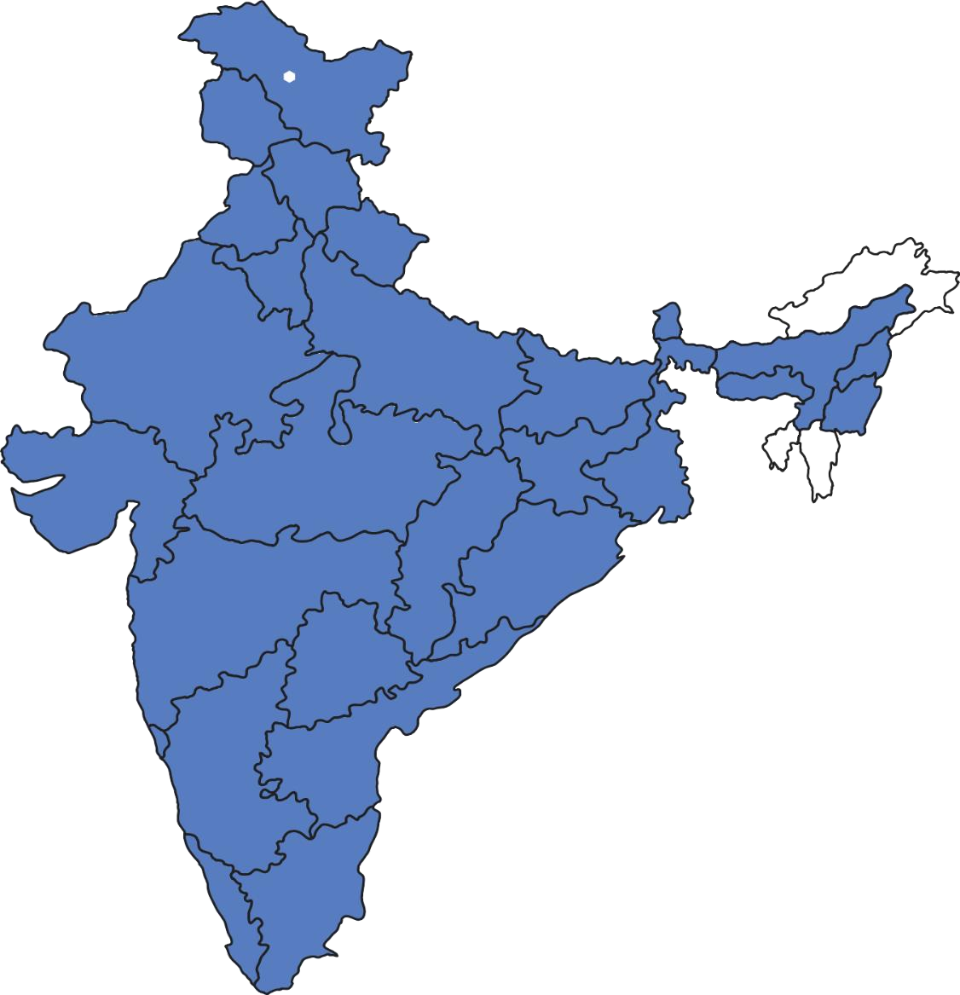
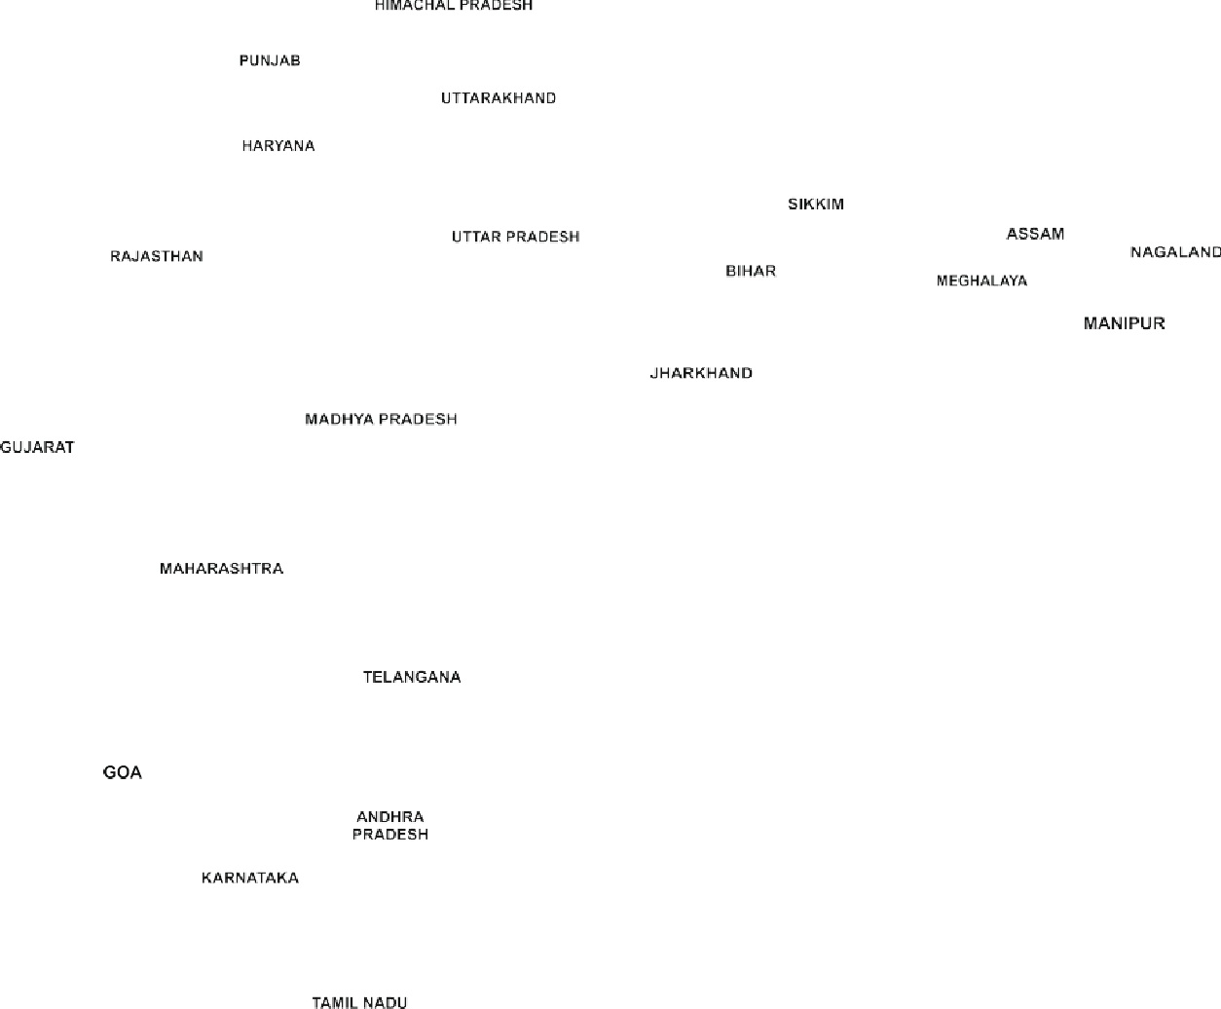
STEM learning has presence in 27 states of India and have proven our process of Installation, delivery- Teachers Training Program along with Monitoring & Evaluation and Maintenance of MSC.

6: Project Implementation Strategy -

6A: School selection and criteria:

- Schools should be for underprivileged children.
- Schools will be such where scientific and math temper among children is not developed and quality education is required to learn in better and easy way.
- Schools are identified by DEO of the location selected and letter will be derived with list of schools mentioned.
- On permission from Funding Partner and principal approval we shall collect following data and individual school letters.
DATA collated:
  - School Address and contact details of HM.
  - Room availability as per out lay plan.
  - Letter of acceptance.
  - Student’s strength in school.
  - No of Teachers (Math’s and science).
  - Gender segregation details.
  - Cumulative grades of students along with number of students in class/division. This report will be known as School Identification Report/Baseline report
6B: Installation -

- An Installation team conducts implementation of 80 models with 40 colourful backdrops and Safety board and 80 placards for each model.
- Pre and post pictures of Installation will be shared.
- Installation report derived.

6C: Teachers Training Program-1st and 2nd

Teachers Training Program- Trainer’s team gets in touch with School authorities- Principal & teachers schedules the training date & venue.

The training consists of:
  - Orientation of Models.
  - Usage as per concepts and its 5 daily usage.
  - Mapped document of Model with curriculum.
  - Establish topics and usage as per the timetable.
  - Explain follow up process
  - WhatsApp support group formation.
  - Expected output from teachers of documentation of usage, as they are plug and play and can be taken to class for demonstration and explanation.
  - Register of MSC, as they are plug and play and can be demonstrated in class during the concept clarity.
  - Identify and prioritize issues to be dealt by teachers.
  - Set up goals for best practice documentation.
  - Inform about M&E visit and process.

The same above process is follow for 2nd Teachers training post. The documents supporting this activity is:
  - Call sheet.
  - WhatsApp group snap shot.
  - Goal set document for output.

  - Teacher’s attendance sheet of training.
  - Pictures and Videos (if possible).

This report will be known as Teachers Training program report.

The above same data will be part of the 2nd Teachers Training Program report. Immediately on receiving closure of installation set up.

6D: Monitoring & Evaluation -

The M&E officer initiates the M&E visit with getting in touch with Principal & teachers of the visit and the same is updated on the WhatsApp group.
Reconfirms the same 72 hours before departure.
The M&E consists of: Collating data on.

    - No. of students per class/division.
    - Cumulative grades of students.
    - Gender segregation.

Finalized questionnaire with support for Principal, Teachers and Students
The Principal and teacher’s questionnaire will be qualitative, students will be quantitative and qualitative with FGD and IDI.
The student’s quantitative tools will be:

    - Fill in the blanks.
    - Match the columns.
    - Questions and 3 options.
    - Pictorial identifications of models.

Qualitative:
FGD and IDI lead questions will be framed for students on actual usage in class and MSC. The same above process is followed for 2nd M&E (1st Year Baseline).
The 2nd M&E will be the 1st year baseline and based on the goal set data will be captured in the 2nd set of
questionnaire, which will be developed. The documents supporting this activity is:
    - Call sheet.
    - WhatsApp group snap shot.
    - Questionnaire.
    - Notes of FDG & IDI.
    - Pictures and Videos (if possible).
    - Raw data in excel.
    - Draft M&E report for EY comments.
    - Finalized M&E report.

This report will be known as 1st M&E report.

6E: Maintenance -

The maintenance team will visit the school after the 1st M&E visit.
The visit will notify the school of visit and reconfirm 72 hours prior to departure

The maintenance will undertake:
    - Repairing and Replacement as and where required.
    - Re-clean the premises.

The free maintenance is for 1st year only, year 2 onwards will be charged. The documents supporting this activity is:
    - Pictures of repaired model.
    - Pictures of replaced model.
    - Signed report of maintenance from Principal & Teacher.

This report will be known as Maintenance report.

7: Methodology -

Research type: Primary Research
Frequency of data collection: Twice in year
Variables used: Teachers, location, students and standard etc.
Sampling: Random sampling
Mode of data collection: FGD/Questionnaire

Data Flow
Donor
Corporate partners hip pers on

Factory Training
Incharge Officer
M&E Officer

Parameters checked during the M&E Process

First M&E Parameters
Sr.  No. | Teachers Parameters | Students Parameters
1 | Usage of the MSC in school | Students awareness on MSC
2 | Installation | Students visits in MSC & Handling the Models
3 | TTP Impact | Students able to explaining the models
4 | Teachers Trained | Students Feedbacks
5 | Need of additional training  /Refresher TTP
6 | WhatsApp activity Group
7 | Usage of Models(Taken in  class/students MSC usage)
8 | Items provided by STEM
9 | School Maintained stock register
10 | MSC Neat & Clean
11 | MSC Registers Maintaining

Second M&E Parameters

Sr. No. | Teachers Parameters
1 | No. of teachers trained
2 | School stock register Maintaining
3 | Additional Support given
4 | Teaching with help of STEM Learning Models
5 | Clarity on MSC Objectives
6 | List of material provided

8A: Outcomes/Result expected -

- Improvement of aptitude of the students in regards of science and mathematics.
- Development of inquisitiveness, critical thinking, problem solving skills and creativity of students.
- Enhancing the skills of teachers by training them to teach in a practical manner.
- Improve teaching pedagogy by use of models in conducting the science and math’s class through better
engagement of teachers in teaching.
- Strengthening of concepts of Science and Mathematics.

8B: Impact Assessment -

- Monitoring Evaluation: Undertake M&E activities for baseline data. M&E team visit twice a year.
- Reports to measure and encourage teachers for the maximum usage of MSC.
- Closely evaluate the students to monitor their interest

9: Financial Implications –

Kokuyo Camlin- Mini Science Centre Budget year 2024-25
SR.NO | ITEM | DESCRIPTION | Standard Cost for 1  School | NOS OF  SCHOOLS - 1 | Budget Cost for number of schools
1 | MINI SCIENCE CENTRE | 80 MODELS + 80 USERS PLACARD+ 36 COLOURFUL BACKGROUNDS + 1 SAFETY PLACARD + 1 TEACHERS MANUAL INCLUDES INSTALLATION, DELIVERY | 385,000 | 1 | 385,000
1 | MINI SCIENCE CENTRE | TOTAL | 385,000 | 1 | 385,000
2 | TRAINING OF TEACHERS (TTP) | Fresh & Refresher Teachers Training Program - TTP (1 - FTTP + 1 - RTTP) 1st year. | 47,200 | 1 | 47,200
2 | TRAINING OF TEACHERS (TTP) | TOTAL | 47,200 | 1 | 47,200
3 | MONITORING & EVALUATION | Base-Line, End-Line Reports (2 times in 1st year) | 47,200 | 1 | 47,200
3 | MONITORING & EVALUATION | TOTAL | 47,200 | 1 | 47,200
4 | ANNUAL MAINTENANCE CONTRACT | Cleaning, Servicing & Repair, if not repairable then replaced as per STEM terms & condition. AMC - renewable from 2nd years onwards. | 47,200 | 1 | 0
4 | ANNUAL MAINTENANCE CONTRACT | TOTAL | 47,200 | 1 | 0
5 | INFRASTRUCTURE | Set up of PLATFORMS & ELECTRIC  connection with sockets & switches from internal Board. | 50,000 | 1 | 50,000
5 | INFRASTRUCTURE | TOTAL | 50,000 | 1 | 50,000
6 | NGO - Admin Charges | M&E, Creating & submission reports - Charges @ 7.5% | 39705 | 1 | 39705
6 | NGO - Admin Charges | TOTAL | 39,705 | 1 | 39,705
Grand Total (1+2+3+5+6) |  |  | 616,305 |  | 569,105
NOTE:
* The entire Budget includes GST @ 18% only.
** The Above quote is valid for 61 days from the date of Submission.
** If required Inauguration and volunteer engagement is customized and at additional cost.
** Volunteer engagement, Quiz competition, Model designing program and Scientist lecture is customized and at additional cost.
** Events can be designed post confirmation of schools, beneficiaries and location.
** Payment terms: - 50% at the time of PO and remaining 50% after installation Report.

10A: Sustainability Plan –

Mini Science Centre also takes care of sustainability part. Mini Science Centre model is sustainable because of the following actions:

- Zero Operation Cost.
- MSC enhances the very basic requirement of the schools to support its existing syllabus.
- A vibrant network of teachers will be available for training 3rd year onwards, creating a peer lead program.

10B: Conclusion -

As the famous saying goes, "It is greater to work to educate a child, in the true and large sense of the world than to rule a state." The real empowerment of a country lies in the hands of the children. There cannot be any weapon bigger than education to empower country. STEM education plays an important role as it pervades every aspect of life.

Our MSC (Mini Science Centre) programmes provides more practical based learning and teaching style of Science and mathematics concept. This would equip the students with better clarity on the application of difficult concepts of Science and mathematics in their syllabus. The clarity of concepts would enable the students to think critically, analyze and explore the new horizons which would eventually benefit the society. The following are the benefits of Mini Science Centres:
Capacity Building of Teachers: MSC enables teachers to explain all the Mathematics, Physics and Science concept in a more effective manner. It saves the teaching time by 50% which means the increase in productivity of the teachers in school.
Improves the scientific temperament of students: Instead of reading from book and listening to teachers, MSCs Plug & Play models involve the students in teaching process which ignites the students’ inquisitiveness and also provide better clarity and logic about the theories.
Encourages Innovation: MSC boost the confidence among the students by educating them with science and mathematics concepts. The new-found scientific temperament in them encourages them to transform their innovative into reality.
Promotes Creativity: Creativity cannot sustain without Science. Whether it is an engineer or an architect, they have to be well versed with science and mathematics theories to create a sustainable design. The knowledge of STEM will allow the creative to use the material and space effectively.

11 A: Work Plan Narrative -

ACTIVITY. | PROCESS NARATIVE. | Means of Verification. | Time  period. | REPORT.
IDENTIFICATIO | STEM initiates the process  post Contract & PO with clarity on geography &no’s of schools required, post that the M&E team connect with DOE, if it’s a government recognized school, {for private aided school [ don’t need DOE permission]  Post letter from DOE, we approach the school authorities and get their acceptance letter along with their contact details of principal and teachers involved, the letter clarifies the ownership details of cleanliness, handling of models, material and electricity, we also share the expected outlay plan  {installation requirement} for MSC set up with school and donor.  DATA collated:  - School location.  - Room availability as per out lay plan.  - Letter of acceptance.  - Student’s strength  in school.  Post this we give work order to our Factory team that will assemble and move on for delivery, prior to departure of | The documents | Contract & | School
N. |  | supporting this activity | PO- 2 | Identification Report
 |  | is: | weeks.
 |  | - DOE letter if applicable  - School letter with details of principal, teacher along with clarity on electricity and maintenance.  - Photos of pre MSC School and room.  - Gender  Segregation details.  - Cumulative grades of students along with number of students in class/division.  This report will be | School Identificati on &
 |  | known as School | Closure – 3-
 |  | Identification Report. | 5 weeks.
 |  | Attached: school
 |  | Identification
 |  | Parameters

INSTALLATION | material the school is checked  by our backend team for its readiness (if any furniture Work then that’s extra to be charged to the donor) [ as per the MSC set up layout plan].  On receiving clearance from the school, the installation team proceeds to the location and starts the installation.  On reaching the Installation team takes picture of the room and then another picture taken after the installation and a letter of successful installation and handing over materials/documents. | The documents supporting this activity is:  - Pre room set up picture.  - Post room set up picture.  - Letter from school of completion of installation of MSC with (80  models, 36  backdrops + 1 safety measure board =37,1- Teachers manual, 80 placards of models).  This will be known as Installation report. | Installation- 3 weeks from school closure.  Installation – 2 days at location, if all is ready. | Installation Report
Teachers  Training Program- 1st. | Trainer’s team gets in touch  with School authorities- Principal & teachers | The documents  supporting this activity is:  - Call sheet. | Immediately  on receiving closure of | 1st Teachers  Training Report.

Teachers Training Program- 2nd. | Schedules the training date &  venue.  72 hours before training – reconfirmation is taken from principal and teachers.  Initiate training, the training consists of:  - Orientation of Models. (attached Training flow document)  - Usage as per concepts and its 5 daily usage. (Attached an example of some concepts)  - Mapped document of Model with curriculum. (attached 7  - 75 Models mappingwith Curriculum)  - Establish topics and usage as per the timetable.  - Explain follow up process  →Phone calls.  →WhatsApp support group formation.  - Expected output from teachers of documentation of usage, as they are plug and play and can be taken to class for demonstration and explanation. (attached Pictures and Video)  - Register of MSC, as they are plug and play and can be demonstrated in class  during the concept clarity. | - WhatsApp  group snap shot.  - Goal set  Document for output.  - Teacher’s attendance sheet of training.  - Pictures and Videos (if possible).  This report will be known as 1stTeachers Training program report.  The above same data will be part of the 2nd Teachers Training Program report. | installation  set up-  10 days from installation the 1-^{st} Teachers training program is undertaken  .  /  15 days after 1st M&E visit. | 2nd Teachers Training Report.

- Identify and prioritize
issues to be dealt by teachers.
- Set up goals for best practice documentation.
- Inform about M&E visit and process.

The same above process is
follow for 2nd Teachers training post.
Follow up Visit | The team initiates the follow up visit with getting in touch with Principal & teachers of the visit and the same is updated on the whatsapp group.  Reconfirms the same 72 hours before departure.  The M&E consists of: Collating data on:  - Nos of students per class/division.  - Cumulative grades of students.  - Gender segregation.  the Principal and teacher’s questionnaire will be qualitative, students will be quantitative and qualitative with FGD and IDI.  The student’s quantitative tools will be:  - Fill in the blanks.  - Match the columns.  - Questions and3 Options. | The documents | 45 days | 1st
1st. |  | supporting this activity | from 1st | Monitoring
 |  | is: | TTP. | &
 |  | - Call sheet.  - Whatsapp group snap shot.  - Questionnaire.  - Notes of FDG &IDI.  - Pictures and Videos (if possible).  - Raw data in excel.  - Draft M&E report and Finalized M&E report.  This report will be |  | Evaluation  Report.  (Formative Baseline)
 |  | known as 1st M&E
 |  | report. | /*-5512

Monitoring & Evaluation-2nd Visit  (1st Year annual report). | 4) Pictorial  Identifications of models.  Qualitative:  FGD and IDI lead questions will be framed for students on actual usage in class and MSC.  The same above process is followed for 2nd M&E (1st Year annual report). | The above similar  process will be used for 2nd M&E (1st year baseline report). | 1st Draft in  3 weeks’ time for M&E visit.  2nd M&E Visit -45-60 days after maintenance visit. | 2nd Monitoring & Evaluation Report ( 1st Years baseline)
Maintenance. | The maintenance will visit the school after the 1st M&E visit.  The visit will notify the school of visit and reconfirm 72 hours prior to departure  The maintenance will undertake:  - Repairing and Replacement as and where required.  - Re-clean the premises.  The free maintenance is for 1st year only, year 2 onwards will be charged. | The documents supporting this activity is:  - Pictures of repaired model  - Pictures of replaced model  - Signed report of maintenance from Principal/Teac her  This report will be known as Maintenance report. | 15th days after 1st M&E visit. | Maintenance Report
Volunteer  Engagement. | During the closure of  contracts the number of activities to be undertaken  along with tentative no of | The documents  supporting this activity is: | This activity  can be built in by discussion | Volunteer  Engagement Report (

 | participants are confirmed  for providing cost.  We provide following avenues for VE:  Community Engagement: - In which we will invite government officials to talk to the school or experts from the organization to give talk on connects between school learning and corporate business to further enhance their knowledge and understanding of the product correlation in real life.  Quiz: The corporate can develop a databank of quiz as games on their existing school subject of Math’s and Science.  Model Learning: As to how various scientific and Mathematical models are developed for easy learning.  Support in creating database of online reference/videos/website to be offered as support reference material.  STEM career opportunities in the Industry- Talk by VE  team on future prospects. | - Picture and Videos.  - Activity  Report.  This will be known as Volunteer engagement report (activity based report will be provided). | With donor  and school. | activity  based)

11 B: Mini Science Centre Work Flow -

Work Order
Annual
Maintenance
2nd Teacher
Training
Program
School
Identification
1st Monitoring
& Evaluation
2nd
Monitoring & Evaluation
MSC
Installation
1st Teacher
Training Program
Annual Report

11 C: Tentative Timeline Plan -

PO &  Contract. | School  Identification. | Installation. | 1-TTP. | 1st Follow  up  . | 2nd T  TP. | Maintenance. | 2nd M&E.(  Annual Report)
1st week | Within 2 -3  weeks from PO. | 3-weeks from  school identification & Closure. | 15 to 20  Days from installation. | 45 days  from 1st TTP.( ?) | 15-20th  Day from 1st Follow- up. | 20 to 25  weeks from Installation | 35th to 40th  week from Installation

12: List of 80 Models -

S. no. | Name of the model | S. no. | Name of the model
1. | Constellation Viewer | 41. | Transverse wave pendulum
2. | Newton's Disc | 42. | Area of triangle
3. | Colour Shadow | 43. | Area of parallelogram
4. | Periscope | 44. | Coupled Pendulum
5. | Kaleidoscope | 45. | Solar Light
6. | Laws of Reflection | 46. | Wind Mill
7. | Corner Mirror | 47. | Shape of earth due to rotation
8. | Infinity Tunnel | 48. | KE PE Track
9. | Magic Water Tap | 49. | Loop The Loop
10. | Total Internal Reflection. | 50. | Rope Puzzle
11. | Fun with Magnets | 51. | Refraction Cylinder
12. | Law of Inertia | 52. | Newton's Cradle
13. | Circle and Ball | 53. | Centrifuge Puzzle
14. | Action and Reaction | 54. | Hand Battery
15. | Parrot in the Cage | 55. | Periodic Table
16. | Zoetrope | 56. | Cone Run Uphill
17. | Pin screen | 57. | Tower Of Pisa
18. | Floating Ball | 58. | Lever
19. | Floating Fan | 59. | Pulley Block
20. | Tornado | 60. | Wheel and Axel
21. | Hand Pump | 61. | Heat Absorption
22. | Anamorph | 62. | Day and Night
23. | Floating Magnets | 63. | Viscosity Tube
24. | Magnetic Field Tube & Immiscible Fluid | 64. | Rock and Minerals
25. | Moment of inertia | 65. | DNA
26. | Lazy Tube | 66. | Lateral Shift
27. | Hyperbola | 67. | Force & types of friction
28. | Magnetic effect of electric current | 68. | Funny mirrors
29. | Pythagoras Model & Moire Pattern | 69. | Marble Slide
30. | Elliptical Carrom Board | 70. | Resonance
31. | Two Congruent Right Triangles | 71. | Weight Illusion
32. | Area of a Circle | 72. | Area of Trapezium
33. | (a+b)2 =a2+2ab+b2 | 73. | Sum of angles of Quadrilateral
34. | (a+b+c)2 = a2+b2+c2+2ab+2bc+2ca | 74. | (A+B)^2 - (A-B)^2 = 4AB
35. | a2-b2=(a+b) (a-b) | 75. | Electric bell
36. | Sum of the angles of a triangle | 76. | Human Torso
37. | Tangram | 77. | Ear & Eye
38. | Parking Puzzle & T puzzle | 78. | Human Joints
39. | Organ pipes | 79. | Plant Cell
40. | Area of rhombus | 80 | Animal Cell

THANK YOU
STEM LEARNING PVT. LTD.

